**ISEC 500 - Information Security Overview**

**Assignment 1 - Lab 1: Implementing Common Protocols and Services**

The requirements for this lab are to capture the screenshot of the below steps from given sections and submit in the word document.

**Part 1**

**challenge #1**

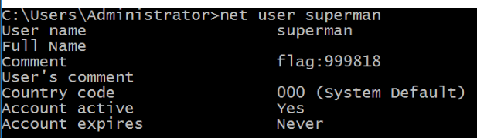

**challenge #2**

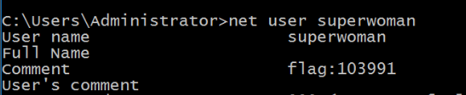

**challenge #3**



**challenge #4**



**challenge #5**

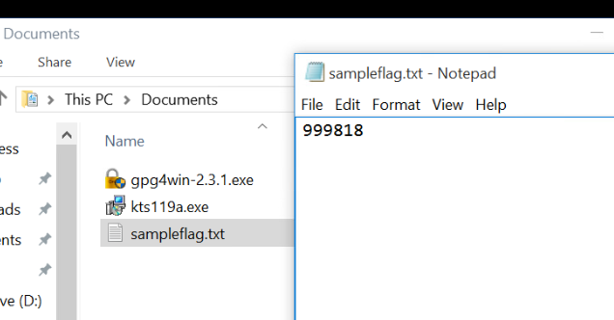

**challenge #6**

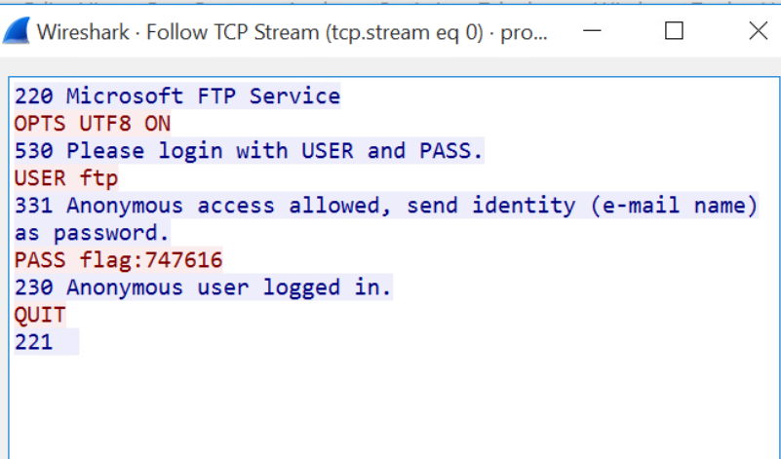

**Screenshots**

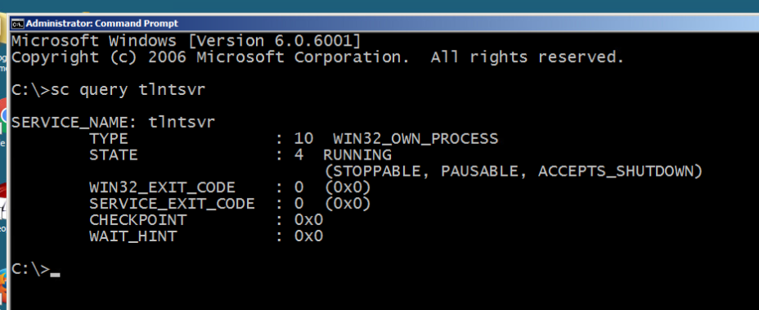

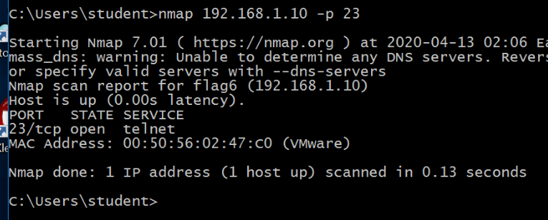

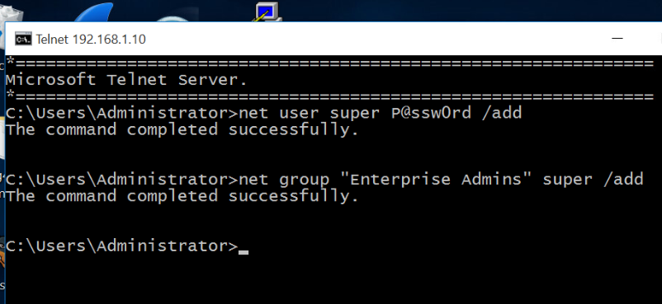

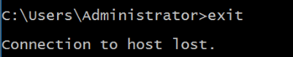

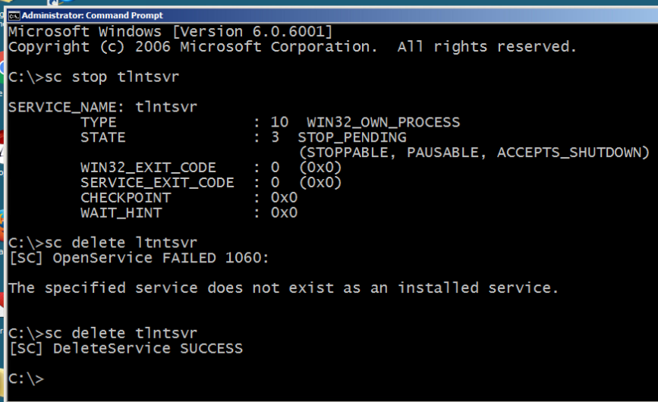

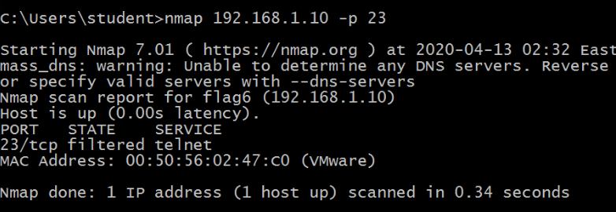

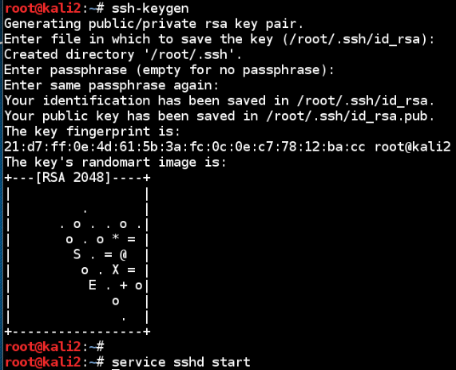

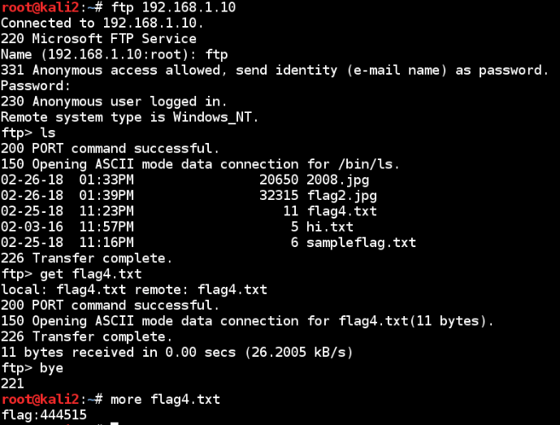

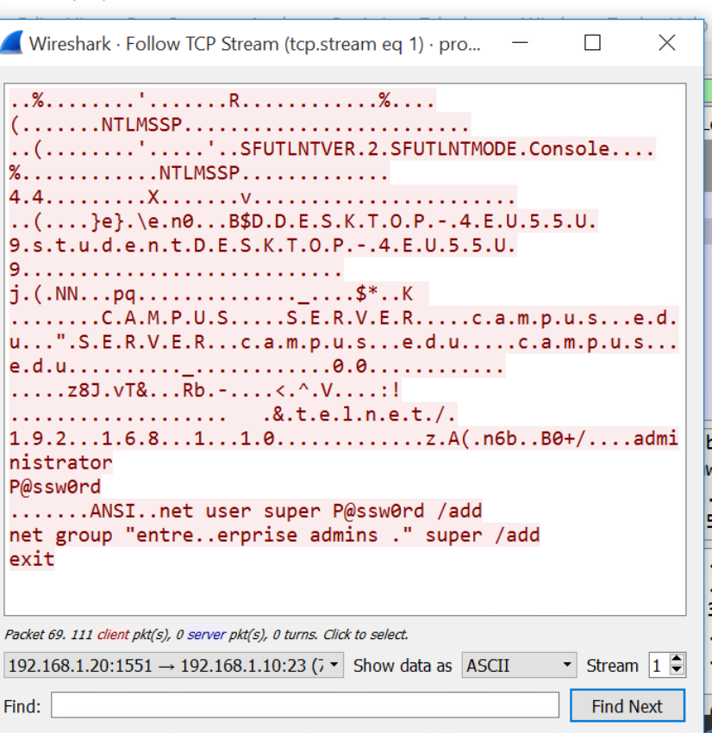

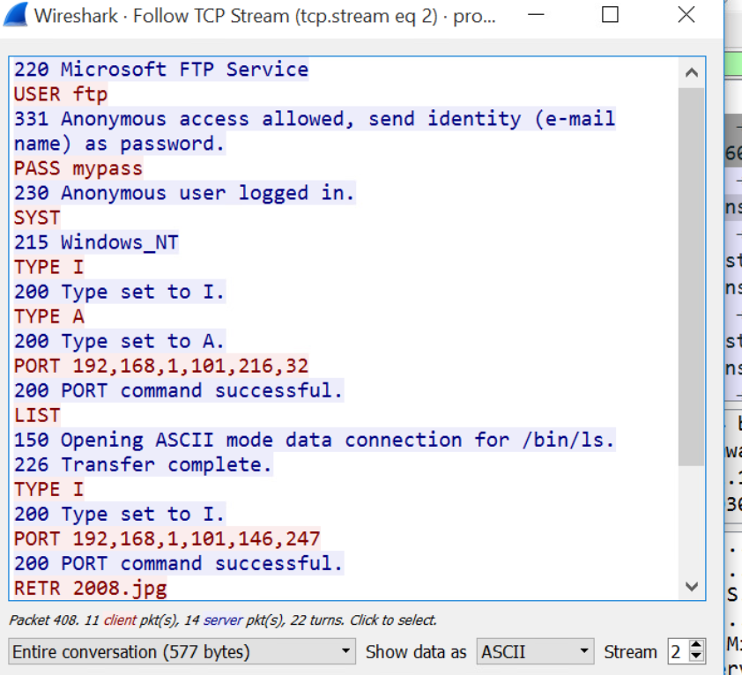

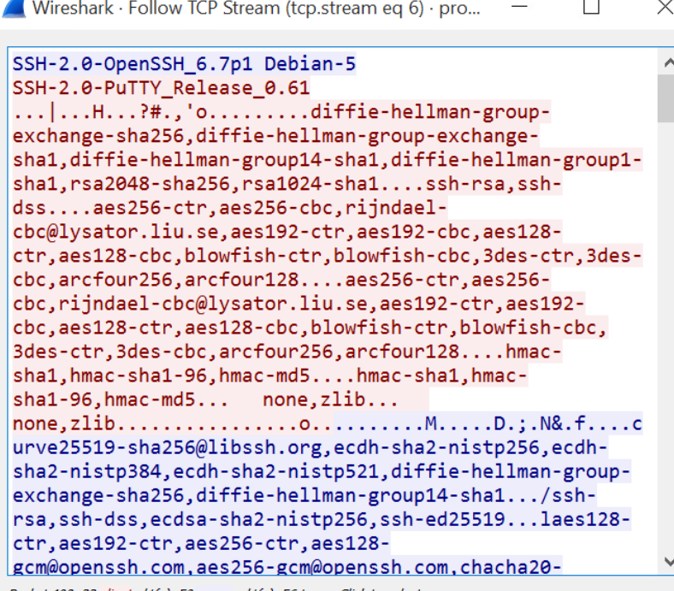

**PART 2**

That was a very informative virtual lab about how computers communicate in real world with no abstractions. I have been to a server farm before for a hardware change on one of the servers of my father’s telecommunication company. So I am guessing telnet is used when you are at the server farm and want to connect to the server over local network. And ssh is used when you are connecting to the server through internet.

We connected to a microsoft server using telnet. We connected to a linux server using ssh.

Then we used FTP to get a file from the windows server. Then we used SCP to get a file from the linux   
server.